_______________________________________________________________________________**Real time hand gesture recognition with python-3 using opencv(cv2)**

**Abstract**—

The goal for the project was to develop a new type of Human Computer Interaction system that subdues the problems that users have been facing with the current system.

The project is implemented on a Linux system but could be implemented on a windows system by downloading some modules for python.

The algorithm applied is resistant to change in background image as it is not based on background image subtraction and is not programmed for a specific hand type;

the algorithm used can process different hand types, recognizes no of fingers, and can carry out tasks as per requirement.

As it is stated within this paper, the main goals were reached. The application is capable of the gesture recognition in real-time. There are some limitations, which we still have to be overcome in future.

**INTRODUCTION**

In today‘s world, the computers have become an important aspect of life and are used in various fields however, the systems and methods that we use to interact with computers are outdated and have various issues, which we will discuss a little later in this paper.

Hence, a very new field trying to overcome these issues has emerged namely HUMAN COMPUTER INTERACTIONS (HCI).

Although, computers have made numerous advancement in both fields of Software and Hardware, Still the basic way in which Humans interact with computers remains the same, using basic pointing device (mouse) and Keyboard or advanced Voice Recognition System, or maybe Natural Language processing in really advanced cases to make this communication more human and easy for us.

Our proposed project is the Hand gestures recognition system to replace the basic pointing devices used in computer systems to reduce the limitations that stay due to the legacy systems such as mouse and Touchpad.

The proposed system uses hand gesture, mostly no of fingers raised within the region of Interest to perform various operations such as Play, Pause, seek forward, seek back word in video player (for instance VLC media player).

A static control board restrains the versatility of client and limits the capacity of the client like a remote can be lost, dropped or broken while, the physical nearness of client is required at sight of activity and that is a limitation of the user.

The proposed system can be used to control various soft panels like HMI systems, Robotics Systems, Telecommunication System, using hand gestures with help of programming by within python using pyautogui module to facilitate interaction within different functions of computer through the Camera to capture video frames.

**APPLICATIONS OF HAND GESTURE RECOGNITION SYSTEM**

A Hand Gesture Recognition System recognizes the Shapes and or orientation depending on implementation to task the system into performing some job.

Gestures is a form of nonverbal information.

A person can make numerous gestures at a time. As humans through vision perceive human gestures and for computer we need a camera, it is a subject of great interest for computer vision researchers such as performing an action based on gestures of the person.

**A. Virtual presence:**

Sometimes in a situation like machine, electricity failure, emergency hostiles condition or some remote areas which are inaccessible to humans, it could very dangerous for human operators to be physically appear to operate the machines or in the working conditions.

So, we can take help of the telepresence where telepresence is the area of intelligence which provides the ability of physical operation.

For instance, the robotic arm maps and repeat the actions performed by the operator arm to carry out a specific operation.

The prospects of Virtual Presence or tele-presence also include applications like space missions, underwater mission, maintenance of nuclear power reactor and anywhere the human presence is not possible or risky.

**B. Bomb disposal:**

Bomb disposal is safer when human beings are substituted by the robot arm which will work on the same concept of hand gestures recognitions. It leads to reduction in the risk of life of a human and it also encourages the efficient handling of the situation.

The robot arm can be used to recognize the postures of a human made by him or her from remote place and it also performs corresponding related function.

C. Based on Wheel-chair: The Individuals in wheel-chair regularly confront issues with manual systems used to control the developments of seat.

Motions of the hand can be embraced with the goal that each signal would be allotted to a specific development. At the point when a specific signal is given the wheelchair moves in a comparing course.

There are numerous utilizations of hand motions acknowledgment which are as of now being used like the gaming business adjusts a considerable measure of hand motion acknowledgment systems in which the utilization of joysticks or consoles is absolutely superfluous these days.

Automated surgeries are likewise led where the specialists work the patients from remote area and the robots play out the errands.

**ALGORITHM**

**a) Data obtaining** –

The initial move is to capture the image from camera and to define a region of Interest in the frame, it is important as the image can contain a lot of variables and these variables can result in unwanted results and the data that needs to be processed is reduced to a large extent.

To capture the image a web-camera is used that continuously captures frames and is used to get the raw data for processing. The input picture we have here is uint8.

The Procured image is RGB and must be processed before i.e. pre-processed before the components are separated and acknowledgement is made.

**b) Data Pre-Processing:**

Pre-processing method can be completed 2-steps process: • Segmentation • Morphological filtering First Process is the Segmentation process.

It is done to change over grey-scale picture into the binary picture so we can have just two Area of Interest in picture.

That is, one will be hand and another one is background. Algorithm can be ‗Otsu

algorithm‘ used for this process and gray scale picture are converted into binary picture having area of interest as the hand and the background.

There are two main approaches to segmentation:

1. Pixel-based or local methods having: - a) Edge detection

b) Boundary detection.

2. Region-based approach: - a) The region merging

b) The region splitting

c) Thresholding method

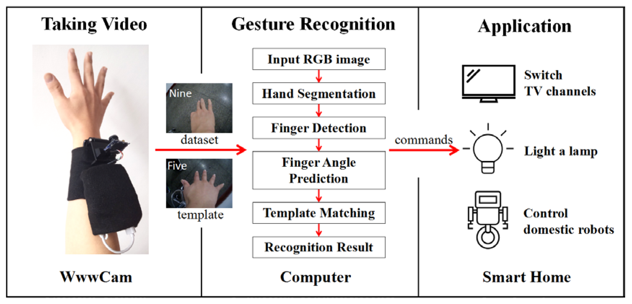(Algorithm Deployed)

Thresholding techniques is employed in partitioning the image pixel histogram by using a single threshold technique. We in this project have used otsu‘sthresholding technique. Otsu‘s thresholding is used to automatically perform clusterbased thresholding.

The method assumes there are two classes of pixels following bi modal histogram and then it calculates optimum threshold separating the two classes

**1. MORPHOLOGICAL FILTERING:**

After thresholding we have to make sure that there will be no noise is present in image, so we are using morphological filtering Techniques, These Techniques are divided in 3 parts.

**1. Contours:**

It implies the direction of hand i.e. regardless of whether the hand is on a horizontal plane or vertically set. Initially, we try to find the orientation by length to width ratio with a presumption that if the hand is vertical ten length of the box bounding them will be more than the width of the same box and, if hand is horizontally placed then width of bounding box is larger than width of the box binding the hand will be more than that of the length of the box.

2. Finding and correcting convex hulls: A hand posture is recognized by its ownorientation and by the fact that how many fingers are shown. For getting the aggregate of how many fingers are shownin hand motions that we have to process just area of the finger of the hand that we have in past advance by figuring out and analyzing the centroid.

3. Math Operations: this can be calculated by - angle = math.acos((b**2 + c**2 - a**2)/(2*b*c)) * 57

This formula determines the angles between the two fingers, for distinguish between the different fingers and to identify them all. We can also determine the length of each raised or collapsed finger coordinate points taking centroid as a source of perspective point, this can be done keeping in mind the end goal to extricate the correct number of finger brought up in the picture.

**CONCLUSION**

With the help of observations that we have, we can conclude that the results should be depend upon:

1. Thresholding. This is the concept of finding contours while converting the gray image to the binary image as the concept of thresholding states. For instance, the lighting over the photo of the hand possibly uneven which is caused by drawing shapes of the contours which is around the dim regions notwithstanding the form around the hand. Changing the limit should be kept that from happening.

2. Background of the pictures should be plain to get accurate analysis of recognition of gestures.

3. Extra occasional keep an eye on minutes is helpful for checking whether the forms of the layout picture and the picture of individual have same shape.

4. For maintaining the performance, the database should contain the template images of small dimension. We observe the following output by implementing algorithm:

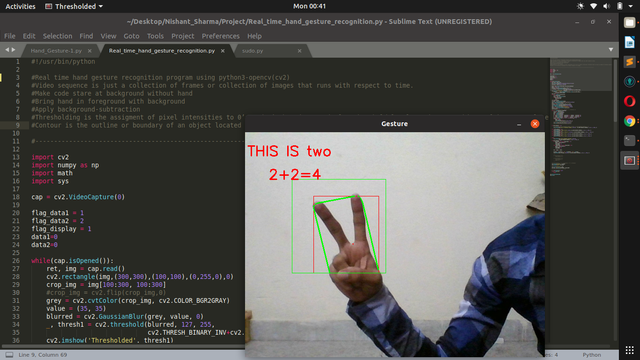

(Output)

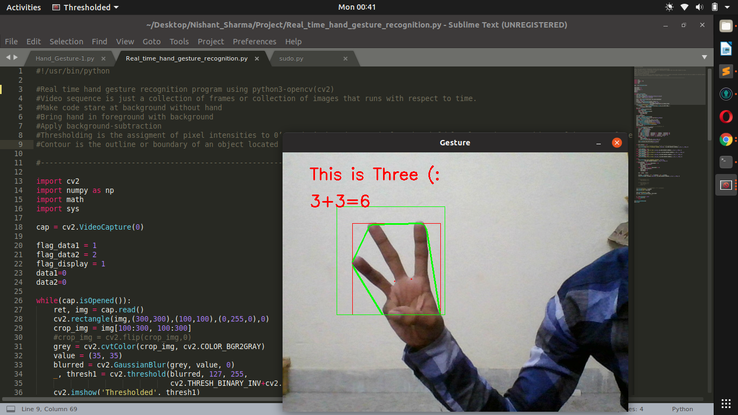(output)

**FUTURE WORK**

This project can be more interactive with the help of tracking real time hand movements and controlling mouse pointer on screen.

The shortcoming of requiring a plain background can be overcome with the help of Background Image substraction or Machine Learning Techniques.

**ACKNOWLEDGMENT**

We would like to thank respected MR. ABHISHEK NAIR SIR for giving me such a wonderful opportunity to expand our knowledge for our CSE branch in software and giving us all the important guidelines to present this report. Sir helps us a lot in realizing.

Submited by :

Nishant Sharma

computer Science and Engineering